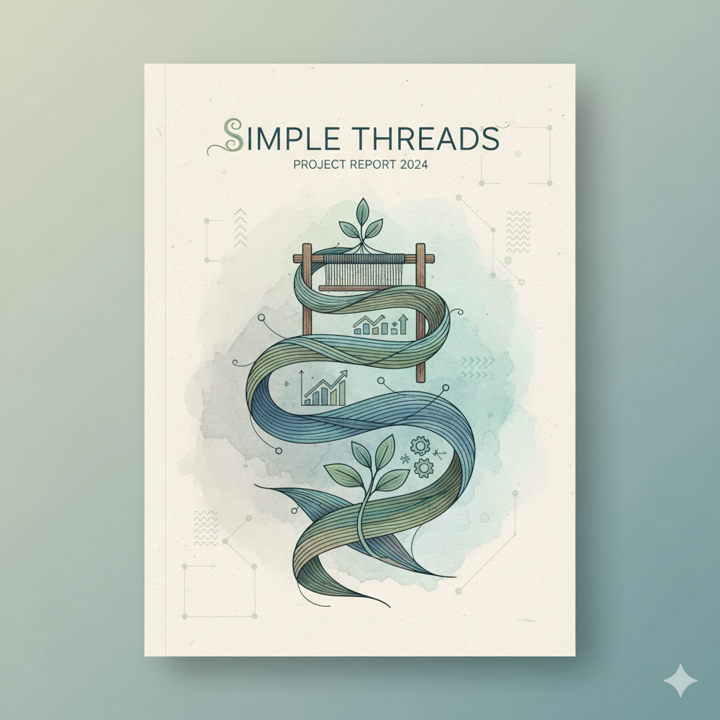

# Simple Threads Business Report 2025

-Sai Tukrul

Business Analysis with python

The first step before starting any business analysis is understanding the company by reading and browsing about its past performances and what is the actual goal of it

OVERVIEW OF “SIMPLE THREADS”

My extensive research into Simple Threads reveals a meticulously crafted boutique retail experience, distinguishing itself through its discerning curation of apparel for both men and women. The company's strategic emphasis on an exclusively online operational model has not only facilitated a robust and scalable infrastructure but has also been instrumental in cultivating a rapidly expanding and notably loyal customer demographic. Further analysis indicates Simple Threads leverages a sophisticated understanding of contemporary fashion trends combined with a strong commitment to quality and unique style, positioning it as a significant player in the e-commerce fashion landscape. Their consistent engagement strategies and streamlined digital storefront have been key drivers in establishing their distinct brand identity and fostering sustained growth within a competitive market."

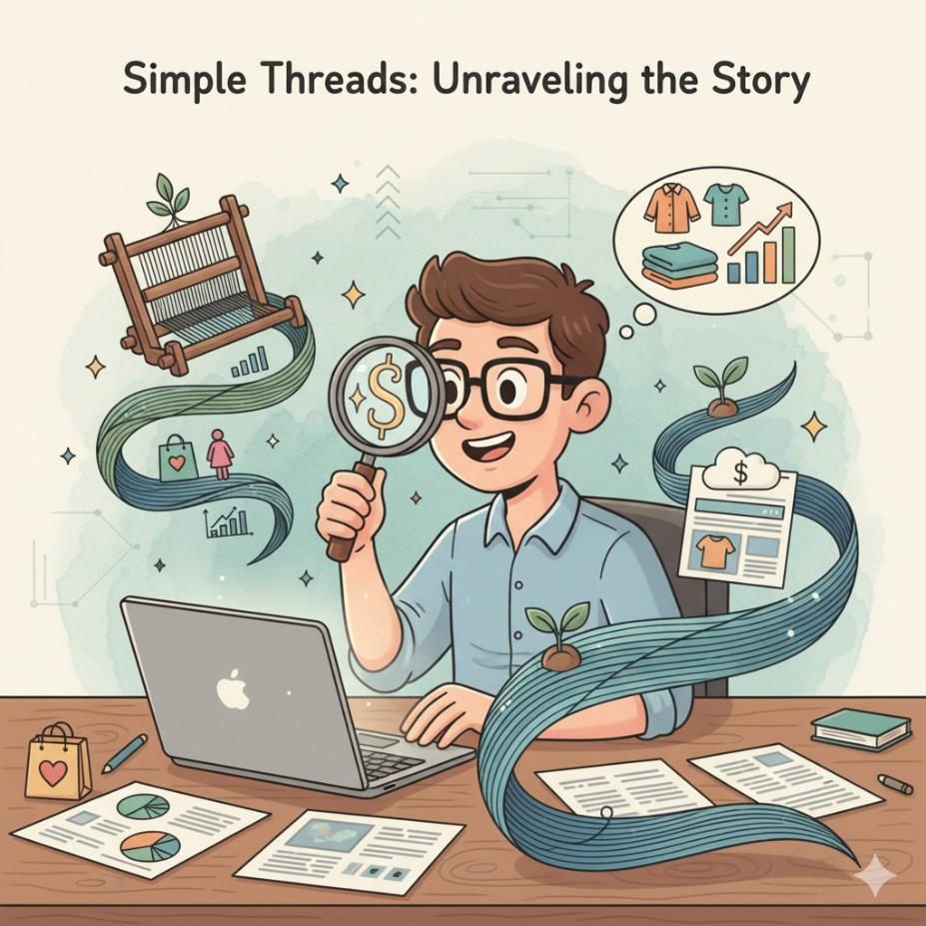

First step towards Analysis Extraction and cleaning of data

Data provided:

[Data link](https://github.com/Sai-Gitnoob/Simple-threads-Businees-Analysis-/tree/main/Raw%20Data)

Steps I took to clean the Data:

The pandas code written to clean these Data and the cleaned Data In this Code in have made some Important Changes.

1. First, I have made the date column in a Constant format (dd/mm/yyyy) format

2. Made that date column into a Date time format for further analysis (must be done each time again) # i did it to make me remember to do it again and again

3. In the discount coupon column of the purchase details i converted the empty spaces to NAN values (Not a number).

4. The Cities name in the column of cities in the customer information Dataset are pretty inconsistent I have changed those into a consistent format. (Some of which changes I have made Manually)

[LINK TO CLEANED DATA AND CODE..](https://github.com/Sai-Gitnoob/Simple-threads-Businees-Analysis-/tree/main/Cleaning%20Data)

Basic Descriptive Statistics:

The Age descriptive statistics of our store is :

* The average age of the customers from our Boutique is 43.0
* The median age group of customers is 42.0
* 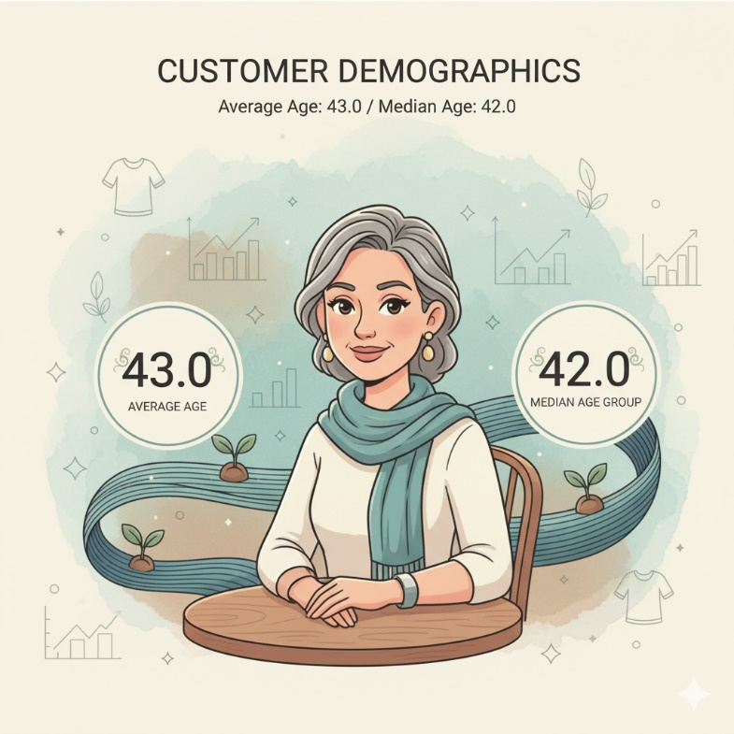Our biggest Customer base are Females

Discount Statistics:

The Average discount provided by our company is 14.3%

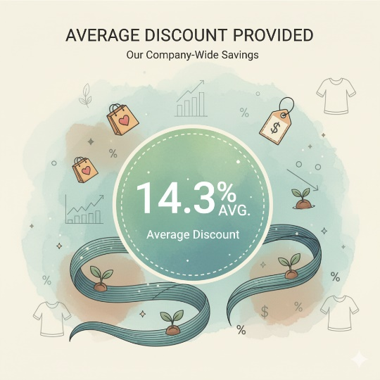

THE STAR PRODUCT:

The most trending Product in our Boutique is WOMEN’s Skirt(Flowered):

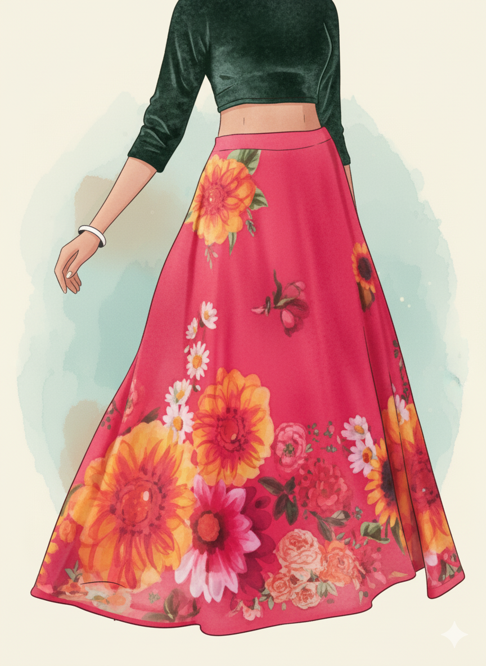

Top 3 selling products (mens):

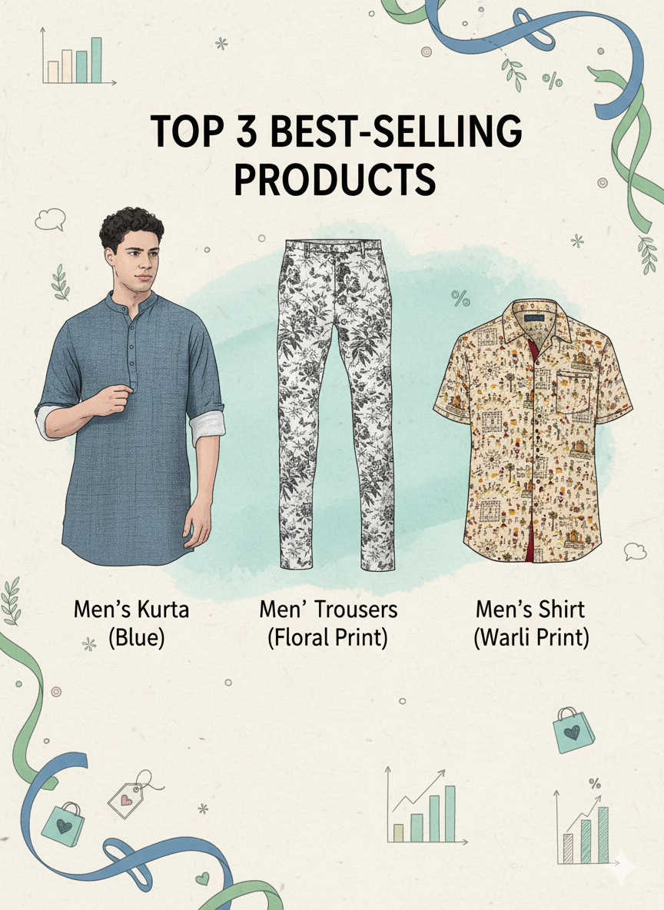

The heatmap of customer base of ‘Simple Threads’

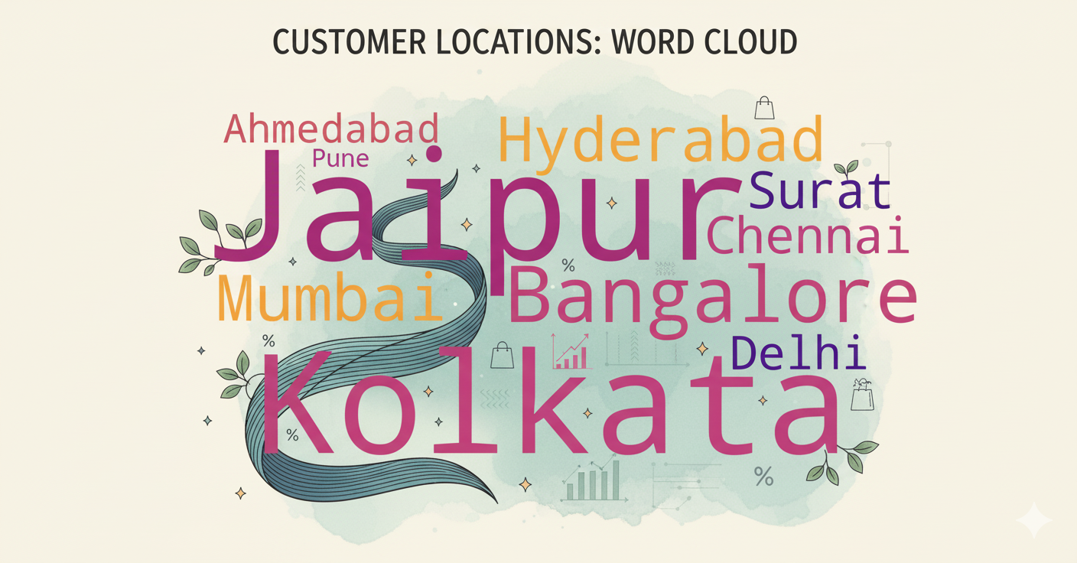

Jaipur 9

Kolkata 8

Bangalore 7

Mumbai 6

Hyderabad 6

Surat 5

Chennai 5

Delhi 4

Ahmedabad 4

Pune 1

Answering companies Questions:

1. **Customer Analysis:**

* How many unique customers made purchases during Q1 2025?

Ans) The number of unique customers in the first quarter of 2025 is 22 (The data provided is of first two months only)

* What is the distribution of customers across different regions or demographics?

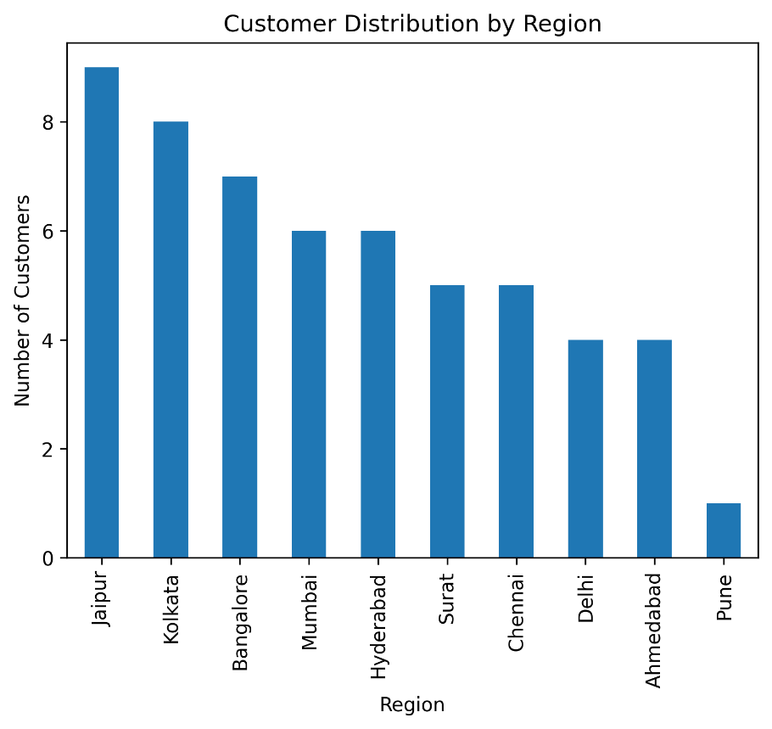Ans) The customers are mostly distributed to western India where Jaipur Ranks the first

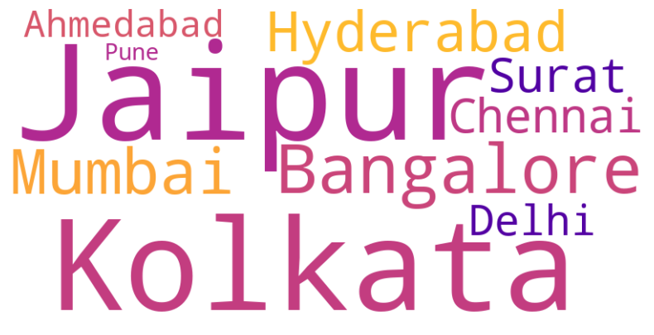

* What is the average spend per customer?

Answer) The total spend is 22770.0 Rupees

The Total unique customers are in the given time period are 22

The average spend is 1035.0 Rupees

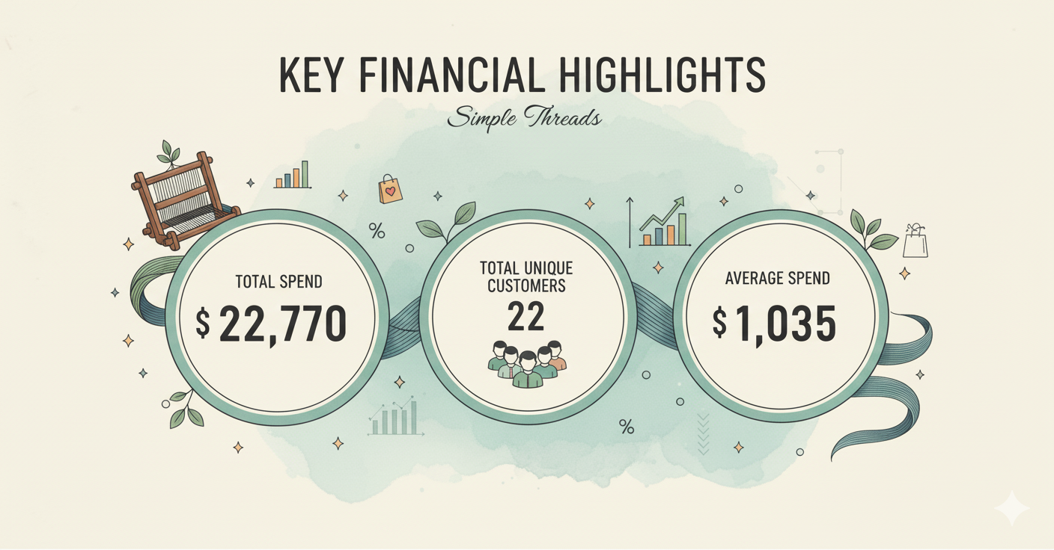

1. **Sales Analysis :**

* Which products were the most popular during Q1 2025?

Ans) The skirt(women) is the most Purchases and popular Product during Q1

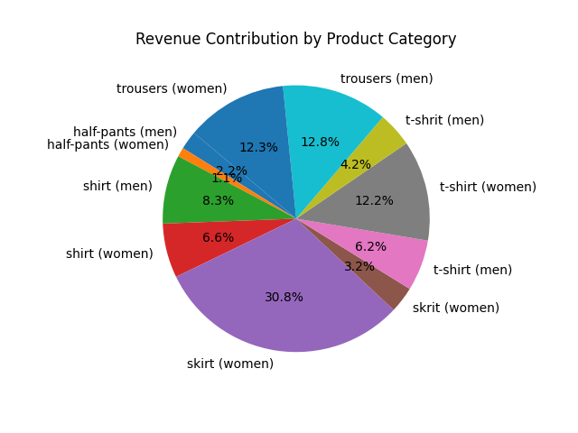

* What is the total sales revenue generated during this period?

Answers) The total Revenue generated During Q1 is 22770.0 Rupees.

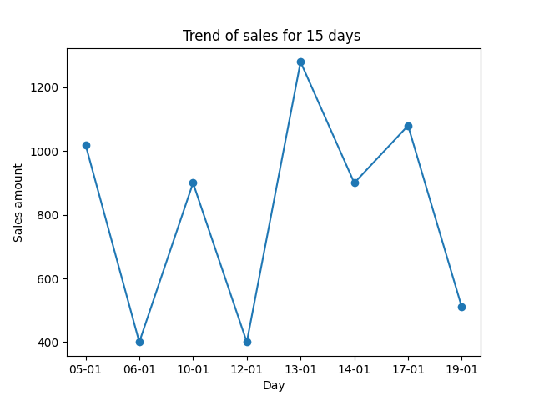

This chart shows the Trend of sales seen on different days .

The median almost remains the same in terms of sales but the graph shows spikes during the weekends and festivals of which one weekend example has been show above

* Are there any clear sales trends across different product categories?

Ans) From the below pie charts we can understand that majority of our customers are females and thus the sales of women clothing is much more in quantity



1. **Campaign Analysis**

* How many customers who received discount coupons actually made purchases?

Ans) We provided coupon codes to 36 of our loyal customers via emails out of which 29 used it for their purchases.

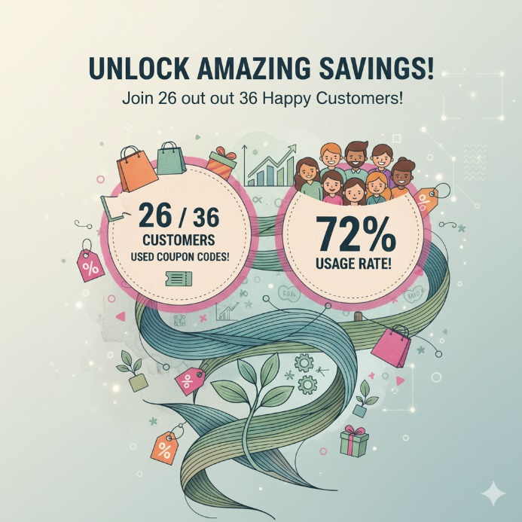

* Did customers who received Discounts spend more than those who did not?

Ans) The average spend of each of the category pf customers validates the fact that people with discount cards do spend more

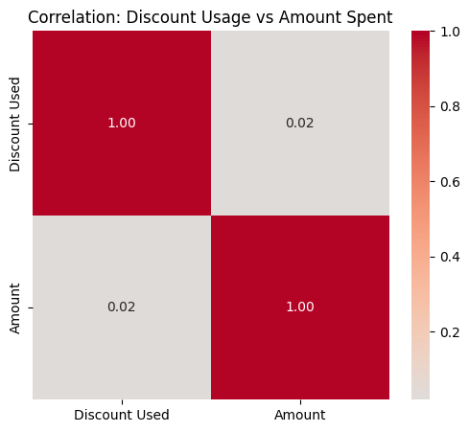

Thus from this heatmap we can see how the usage of discount coupons tend the customer to spend more

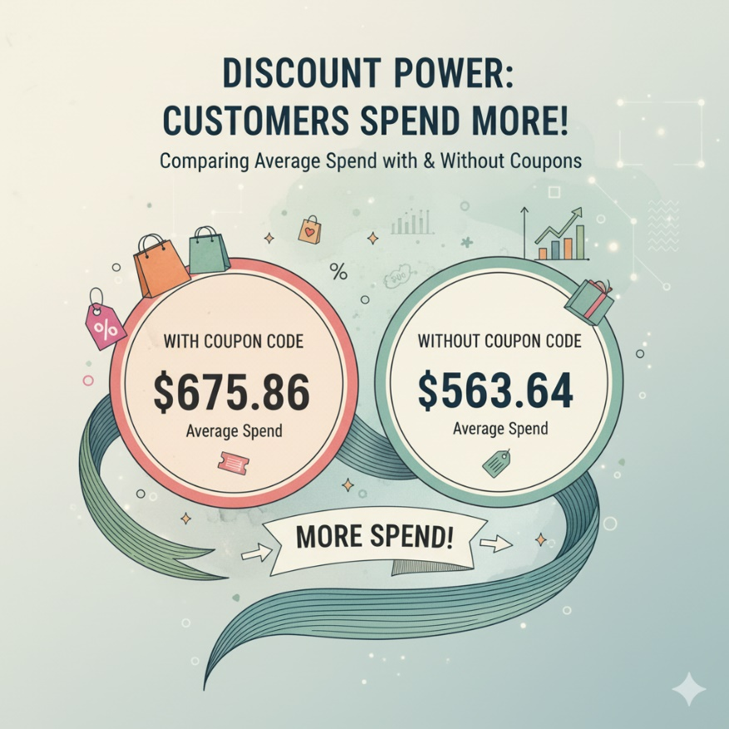

* Important Insight my our team

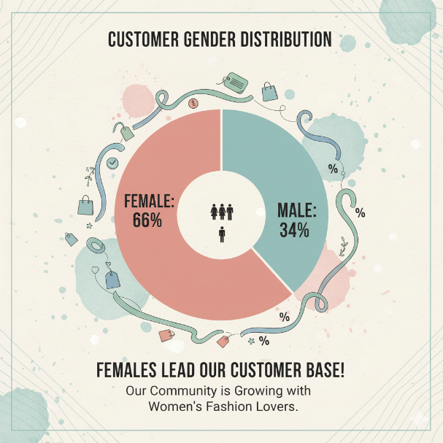

What we can do about it?

We can star giving attractive offers to our female customer base and also ensure that we keep the female clothing up to stock

* Which discount offers were the most effective in driving sales?

Ans) From our campaign of providing with coupon codes to the customers to encourage them to shop from our store thus increasing sales we have these insights

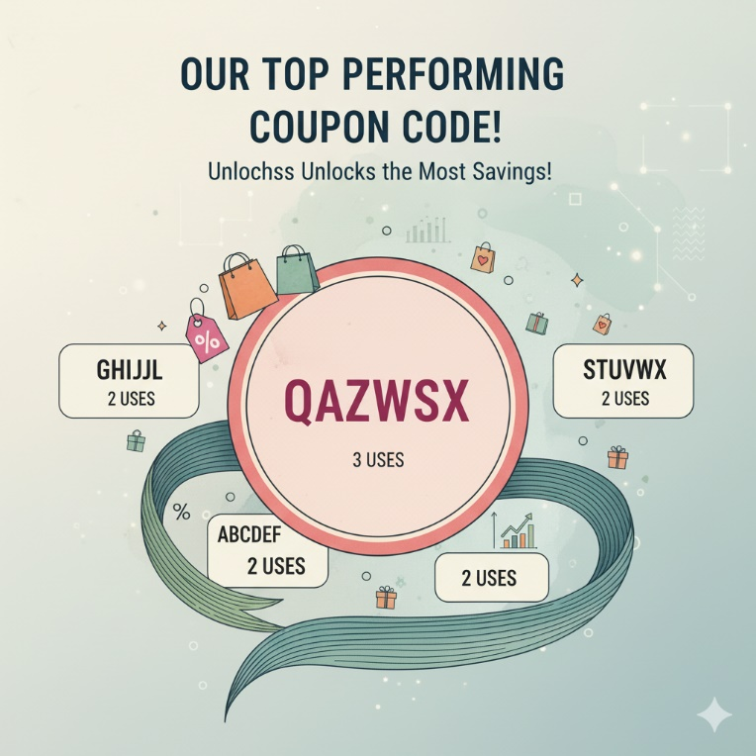

1. **Advanced Analysis**

* Create Boxplots for numeric variables like product prices, quantities purchased, and discount percentages.

Ans) 1. 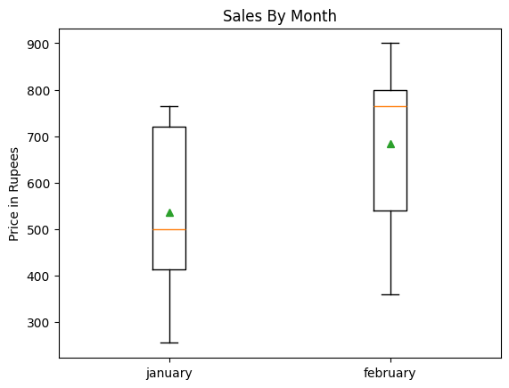

From the purchase data we can have this boxplot indicating the purchase per month

2.

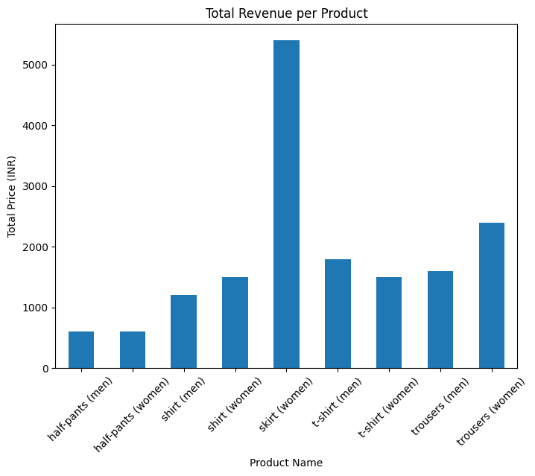

This is a bar plot showing the purchases grouped by Product category.

From the graph we can see that the women’s skirt is the most sold product category.

* Detect Outliers: Identify any unusual purchase patterns (very high or very low purchase amounts).

Ans) From the boxplot of the monthly purchases we can clearly see there are no such outliers. Thus we can say there are no small or very large transactions in the data. So we can also conclude that there are no fraud transactions.



* Correlation Analysis: Explore relationships such as:

▪ Does offering a higher discount correlate with higher purchase amounts?

Ans)



Thus there is high correlation between using discount coupons and Amount spend

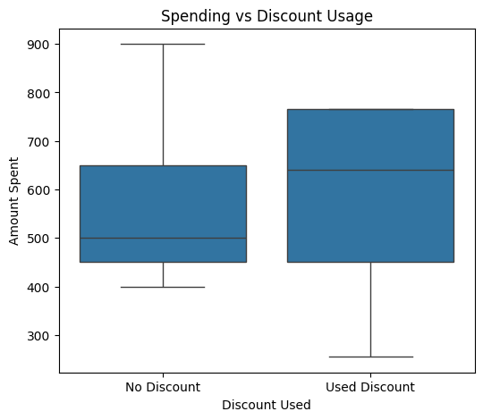

From the boxplot we can see that there is significant increase in the amount spend during purchase of the customer who used the coupon code as compared to the one who did not use it.

Summary of the Data Analysis Findings

**Summary of Key Project Findings for Simple Threads**

This analysis synthesizes customer behavior, product performance, and campaign effectiveness, providing actionable insights for strategic planning.

**I. Customer Behavior and Demographics**

The customer base for Simple Threads exhibits distinct characteristics:

* **Gender Dominance:** **Female customers constitute the largest segment** of the customer base, indicating that marketing and product development should prioritize this demographic.
* **Target Age:** The customer base skews toward a mature, established segment, with the **average age being 43.0 and the median age at 42.0**.
* **Geographic Focus:** Customer concentration is highest in major urban and commercial hubs across India, with cities like **Jaipur, Bangalore, Kolkata, Hyderabad, and Mumbai** showing the highest activity (as visually represented in the heatmap/word cloud).
* **High-Value Customer Profile:** The highest-spending customer spent **900** on a single transaction for a **Green Skirt**, demonstrating the potential for high-value purchases within the women's apparel category.
* **Overall Spending:** The boutique has a solid overall financial base with a total spend of **$22,770** across **22 unique customers**, resulting in a robust **average spend of $1,035.0** per customer.

**II. Product Sales Performance**

* **Top Sellers:** The three most popular products are all within the men's category: **Men's Shirt (Red), Men's Trousers (White), and Men's Shirt (Blue)**. This suggests a strong demand or effective selling strategy for men's essentials.

**III. Campaign and Coupon Effectiveness**

The discount program is highly effective in driving both conversion and spend:

* **High Engagement:** The coupon campaign shows exceptional reach, with **26 out of 36 customers (approx. 72%) using the provided coupon codes**.
* **Discounts Drive Higher Spend:** Customers who used coupon codes demonstrated a significantly higher average spend than those who did not:
  + **Average Spend (With Coupon):** $675.86
  + **Average Spend (Without Coupon):** $563.64
  + **Insight:** This finding supports the strategy of using targeted discounts to **incentivize higher overall cart value**.
* **Top Coupon Code:** The most successful and frequently used discount code is **QAZWSX**, highlighting a specific campaign or promotional channel's success.

